Name: - Vishal Singh
Roll no: -

LAB Exercise
Set A
a. Write a JavaScript function to validate email-id using regular expression.

<!DOCTYPE html>
<html lang="en">

<head>
<meta charset="utf-8">
<title>JavaScript form validation - checking email</title>
<link rel='stylesheet' href='style.css' type='text/css' />
</head>
<style>
li {
list-style-type: none;
font-size: 16pt;
}
.mail {
margin: auto;
padding-top: 10px;
padding-bottom: 10px;
width: 400px;
background: #d8f1f8;
border: 1px soild silver;
}
.mail h2 {
margin-left: 38px;
}
input {
font-size: 20pt;
}
input:focus,
textarea:focus {
background-color: lightyellow;
}
input submit {
font-size: 12pt;
}
.rq {
color: #ff0000;
font-size: 10pt;
}
</style>
<script>
function ValidateEmail(inputText) {
var mailformat = /^[a-zA-Z0-9.!#$%&'*+/=?^_`{|}~-]+@[a-zA-Z0-9-]+(?:\.[a-zA-Z0-9-]+)*$/;
if (inputText.value.match(mailformat)) {
alert("Valid email address!");
document.form1.text1.focus();
return true;
}
else {
alert("You have entered an invalid email address!");
document.form1.text1.focus();
return false;
}
}

</script>
<body onload='document.form1.text1.focus()'>
<div class="mail">
<h2>Input an email and Submit</h2>
<form name="form1" action="#">
<ul>
<li><input type='text' name='text1' /></li>
<li>&nbsp;</li>
<li class="submit"><input type="submit" name="submit" value="Submit"
onclick="ValidateEmail(document.form1.text1)" /></li>
<li>&nbsp;</li>
</ul>
</form>
</div>
</body>

</html>

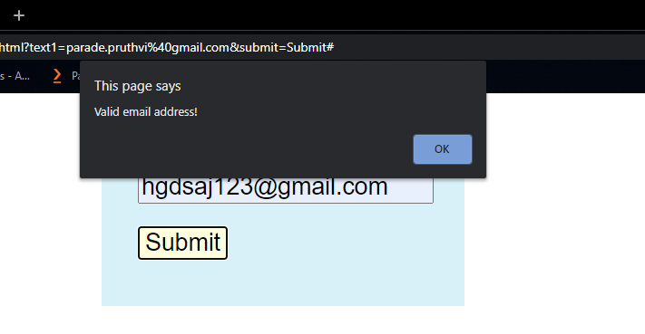

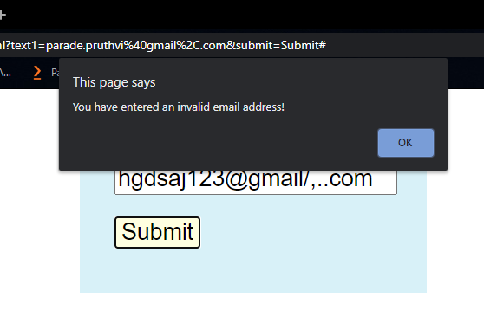

b. Write a JavaScript program for accepting name and mobile number from user and perform following validation:
i. Check all fields should not contain a null value
ii. Check name field contains only alphabets
iii. Mobile No. field should be of 10 digits long.

<!DOCTYPE html>
<html lang="en">

<head>
<meta charset="utf-8">
<meta http-equiv="content-type" content="text/html; charset=utf-8" />
<title>JavaScript form validation - checking all letters</title>
</head>
<script>
function validate() {
var a = document.getElementById("mobilenumber").value;
var b = document.getElementById("user_name").value;
if (a == "") {
document.getElementById("messages").innerHTML = "plz enter number";
return false;
}
if (isNaN(a)) {
document.getElementById("messages").innerHTML = "Numeric Value only";
return false;
}
if (a.length < 10) {
document.getElementById("messages").innerHTML = "Mobile number must be 10 digit only";
return false;
}
if (a.length < 10) {
document.getElementById("messages").innerHTML = "Mobile number must be 10 digit only";
return false;
}
if ((a.charAt(0) != 9) && (a.charAt(0) != 8) && (a.charAt(0) != 7)) {
document.getElementById("messages").innerHTML = "Mobile number should start with 9 or 8 or 7";
return false;
}
else {
document.write("Mobile number accepted");
}
if (b == "") {
document.getElementById("mes").innerHTML = "Name is Null";
}
else {
document.write("<br>Name accepted");
}
}
</script>

<body>
<h2>Enter your Name and Submit</h2>
<form onsubmit="return validate()">
<h4>Mobile Number</h4><input type="text" id="mobilenumber">
<span id="messages"> </span><br><br>
<input type="text" id="user_name">
<span id="mes"> </span><br><br>
<input type="submit" value="Submit">

</form>
</body>

</html>

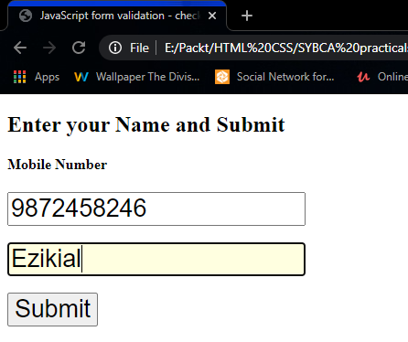

Set B

2. Write a Java Script program to design Customer Account Details Form and perform validation on pan number field. (pan number is of only 10 characters long, out of which first 5 characters are alphabets, next 4 characters are digits and last character is alphabet)

<!DOCTYPE html>
<html lang="en">

<head>
<meta charset="UTF-8">
<meta name="viewport" content="width=device-width, initial-scale=1.0">
<title>Document</title>
</head>
<script>
function ValidatePAN() {
var txtPANCard = document.getElementById("txtPANCard");
var lblPANCard = document.getElementById("lblPANCard");
var lblPANCard2 = document.getElementById("lblPANCard2")
var regex = /^[A-Z]{5}[0-9]{4}[A-Z]{1}$/;
if (regex.test(txtPANCard.value.toUpperCase())) {
lblPANCard.style.visibility = "visible";
document.getElementById("lblPANCard").innerHTML = "Valid PAN NUMBER";
} else {
lblPANCard.style.visibility = "visible";
document.getElementById("lblPANCard").innerHTML = "Invalid PAN NUMBER";
}
}
</script>
<style type="text/css">
.PAN {
text-transform: uppercase;
}

.error {
color: Red;
visibility: hidden;
}
</style>

<body>
<label for="pan_number">Enter your PAN NUMBER : </label>
<input name="txtPANCard" type="text" id="txtPANCard" class="PAN" />
<span id="lblPANCard" class="error"></span>
<hr/>
<input type="button" id="btnSubmit" value="Submit" onclick="ValidatePAN()" />
</body>

</html>

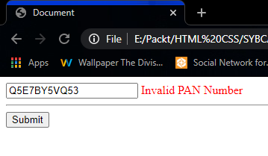

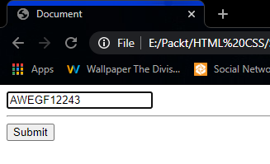

3. Design a form to accept product name, quantity, rate and discount for the product purchased by the user. Write a JavaScript code to calculate total bill. If quantity is less than 5 then there is any discount, If quantity is greater than 5 and less than 25 then discount is 5%, If quantity is greater than 25 and less than 50 then discount is 15%, If quantity is greater than 50 discount is20%.

<!DOCTYPE html>
<html lang="en">

<head>
<meta charset="UTF-8">
<meta name="viewport" content="width=device-width, initial-scale=1.0">
<title>Assignment 10 SET B Q2</title>
</head>
<script>
function total() {
var q = parseInt(document.getElementById("Qauntity").value);
var r = parseInt(document.getElementById("Rate").value);

if (q <= 5) {
document.getElementById("output").innerHTML = "Total : " + r * q;
} else if (q > 5 && q < 25) {
document.getElementById("output").innerHTML = "Total : " + parseInt((r * q) - ((r * q) * 5) / 100);
} else if (q > 25 && q < 50) {
document.getElementById("output").innerHTML = "Total : " + parseInt((r * q) - ((r * q) * 15) / 100);
} else {
document.getElementById("output").innerHTML = "Total : " + parseInt((r * q) - ((r * q) * 20) / 100);
}
}
</script>

<body>
<table>
<tr>
<td></td> <label>Product Name:</label></td>
<td><input type="text" id="name"></td>
</tr>
<tr>
<td><label>Qauntity : </label></td>
<td><input type="text" id="Qauntity"></td>
</tr>
<tr>
<td><label>Rate(per) : </label></td>
<td><input type="text" id="Rate"></td>
</tr>
<tr>
<td><button onclick="total()">Total</button></td>
</tr>
</table>
<p id="output"></p>
</body>

</html>
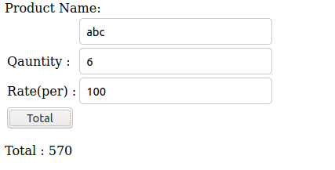

Set C

1. Write a JavaScript code to change the background colour of the webpage

<!DOCTYPE html>
<html lang="en">
<head>
<meta charset="UTF-8">
<meta name="viewport" content="width=device-width, initial-scale=1.0">
<title>Assignment 10 SET C Q1</title>
</head>
<script>
function change(){
var color = document.getElementById("bg").value;
document.body.style.background = color;
}
</script>
<body>
<label for="color">Select color for Background : </label>
<select id="bg" onchange="change()">
<option value="white">White</option>
<option value="red">Red</option>
<option value="green">Green</option>
<option value="black">Black</option>
<option value="yellow">Yellow</option>
<option value="blue">Blue</option>
<option value="orange">Orange</option>
</select>
</body>
</html>

2. Write a menu driven program using JavaScript code to perform followingoperations,
a. Jump to the previous webpage
b. Jump to the next webpage
c. Jump to the two page before from currentpage
d. Jump to the two page after from current page.

Page 1
<!DOCTYPE html>
<html lang="en">

<head>
<meta charset="UTF-8">
<meta name="viewport" content="width=device-width, initial-scale=1.0">
<link rel="stylesheet" href="style.css">
<title>Page 1</title>
</head>
<style>
* {
padding: 0;
margin: 0;
}

.btn1 {
margin-right: 50px;
margin-left: 50px;
border: none;
outline: none;
height: 50px;
width: 100px;
background-color: black;
color: #fff;
border-radius: 4px;
font-weight: bold;
}
.btn1:hover {
background-color: #fff;
border: 1px solid;
color: black;
}
</style>
<body>
<center>
<h1>This is the first page</h1>
<br><br><br>
<a href="page2.html"><button type="button" class="btn1">NEXT</button></a> <br>
<a href="page3.html"><button type="button" class="btn1">3rd Page</button></a>
</center>
</body>

</html>

Page 2
<!DOCTYPE html>
<html lang="en">

<head>
<meta charset="UTF-8">
<meta name="viewport" content="width=device-width, initial-scale=1.0">
<link rel="stylesheet" href="style.css">
<title>Page 2</title>
<style>
* {
padding: 0;
margin: 0;
}

.btn1 {
margin-right: 50px;
margin-left: 50px;
border: none;
outline: none;
height: 50px;
width: 100px;
background-color: black;
color: #fff;
border-radius: 4px;
font-weight: bold;
}

.btn1:hover {
background-color: #fff;
border: 1px solid;
color: black;
}
</style>
</head>

<body>
<center>
<h1>This is the second page</h1>
<br><br><br>
<a href="page1.html"><button type="button" class="btn1">Previous</button></a> <br>
<a href="page3.html"><button type="button" class="btn1">NEXT</button></a> <br>
<a href="page4.html"><button type="button" class="btn1">4th Page</button></a> <br>
</center>
</body>

</html>

Page 3
<!DOCTYPE html>
<html lang="en">

<head>
<meta charset="UTF-8">
<meta name="viewport" content="width=device-width, initial-scale=1.0">
<link rel="stylesheet" href="style.css">
<title>Page 3</title>
<style>
* {
padding: 0;
margin: 0;
}

.btn1 {
margin-right: 50px;
margin-left: 50px;
border: none;
outline: none;
height: 50px;
width: 100px;
background-color: black;
color: #fff;
border-radius: 4px;
font-weight: bold;
}

.btn1:hover {
background-color: #fff;
border: 1px solid;
color: black;
}
</style>
</head>

<body>
<center>
<h1>This is the third page</h1>
<br><br><br>
<a href="page2.html"><button type="button" class="btn1">Previous</button></a> <br>
<a href="page1.html"><button type="button" class="btn1">1st Page</button></a> <br>
<a href="page4.html"><button type="button" class="btn1">Next</button></a> <br>
</center>
</body>

</html>

Page 4
<!DOCTYPE html>
<html lang="en">

<head>
<meta charset="UTF-8">
<meta name="viewport" content="width=device-width, initial-scale=1.0">
<link rel="stylesheet" href="style.css">
<title>Page 1</title>
<style>
* {
padding: 0;
margin: 0;
}

.btn1 {
margin-right: 50px;
margin-left: 50px;
border: none;
outline: none;
height: 50px;
width: 100px;
background-color: black;
color: #fff;
border-radius: 4px;
font-weight: bold;
}

.btn1:hover {
background-color: #fff;
border: 1px solid;
color: black;
}
</style>
</head>

<body>
<center>
<h1>This is the fourth page</h1>
<br><br><br>
<a href="page3.html"><button type="button" class="btn1">Previous</button></a> <br>
<a href="page2.html"><button type="button" class="btn1">2nd Page</button></a> <br>
</center>
</body>

</html>

